High Level Design Document (HLD) v1.0

Project Management

Project Number #
Project Name
CR #
Business Owner
Functional Area
Description

Change Management

IT Review
Role | Name | Revision # | Comments | Date | Initials
Technical Team Lead
Solutions Team Lead
ARB Team Lead
Project Mgmt Team Lead

Revision History
Date | Revision # | Author | Comments

Table of Contents
1. Introduction 3
2. Requirements Traceability to Design Elements 4
3. Design Overview 4
3.1.1. Design Summary 4
3.1.2. Component Summary 4
4. Design Assumptions 5
5. Design Risks 5
6. Architecture Implications 5
7. Error Handling 5
8. Test Plans 5
8.1.1. System Test Cases 5
8.1.2. Integration Test Cases 5
9. Appendices 5

Introduction

The high level design should provide the architectural overview for addressing the Features identified in the SRD. This is where the designer can identify opportunities for reuse of systems, modules and components. The first step is to create a conceptual design (sometimes a block diagram is used) to depict the vision. From there, the designer needs to map the design elements back to the Non-Functional Features (which again are used to support the Functional Features). The design should highlight ALL of the components required to support the overall design (screens, interfaces/services, reports, functional objects and associated configuration tables). The designer needs to document the assumptions that he/she used to create the design (these are typically engineering assumptions). If the design introduces any risks and/or does not address key risk areas, then the designer needs to highlight those for the project manager for communication. Note: These are especially important when artificial constraints are imposed on the designer from the business or external sources. The Architecture Impacts need to be assessed to address impacts to other systems, key dependencies, failure points or non-compliance with existing architecture standards. Finally, the designer needs to address concerns with business continuity for the solution and document the test cases for System & Integration Testing.

Step 1: Trace all of the Non-Functional Features back to the Design Elements in the HLD
Step 2: Document the proposed solution (picture w/ description) & identify the components (TBD in LLDs)
Step 3: Capture the assumptions used to create the solution
Step 4: Capture the risks associated with the design
Step 5: Document the Architecture Implications from the proposed design (esp. where we deviate from stds)
Step 6: Identify the Error Handling Requirements to address resiliency & adaptability in the design
Step 7: Document the Test Plans covering System & Integration Test Cases
Step 8: Document any research or reference materials used to support the design

Development Methodology

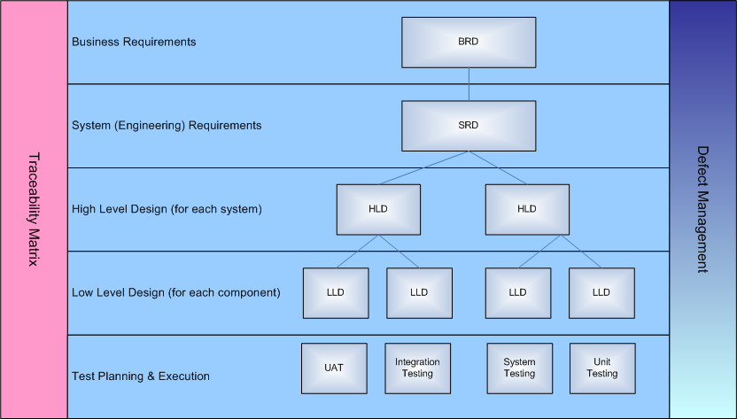

Requirements Traceability to Design Elements
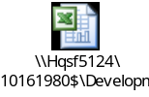

Design Overview
[This section describes how the system works today. It also describes the actors who currently uses the system, the workflow and existing use cases - how the actors are using the system].

Design Summary

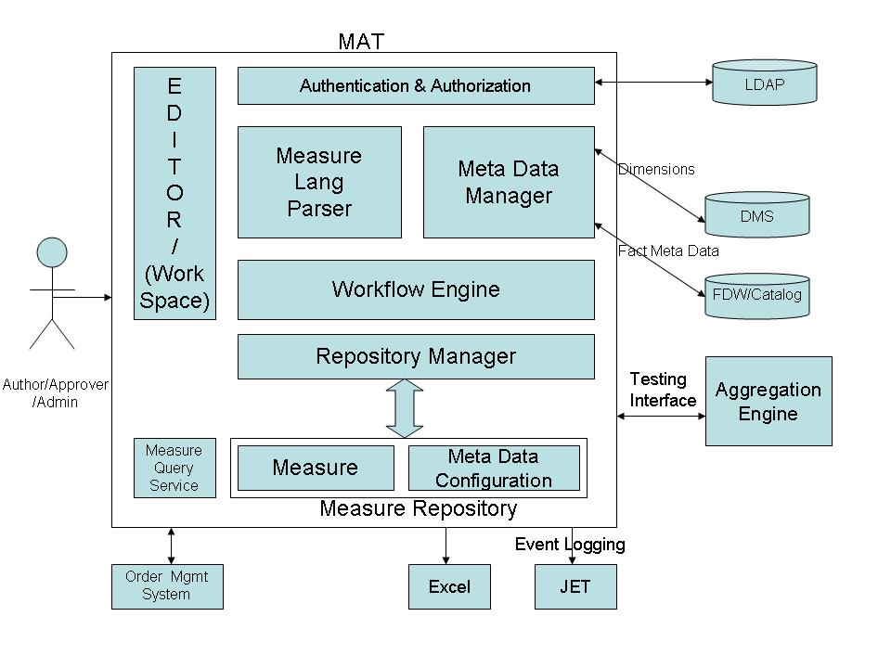

Component Summary

Embed xls

Design Assumptions
This section reminds the reader the functionality, components or business process not included in this project.

Design Risks
This section reminds the reader the functionality, components or business process not included in this project.

Architecture Implications
This section reminds the reader the functionality, components or business process not included in this project.

Error Handling

Embed xls

Test Plans
[This section describes how the system works today. It also describes the actors who currently uses the system, the workflow and existing use cases - how the actors are using the system].

System Test Cases

ints

Integration Test Cases

Embed xls

Appendices

